- Introduction
In India we don’t have any direct communication between the government and public in an efficient way for solving the problems i.e., for getting a problem solved in our place we have to bribe the officials and get them solved in 2 months which can be solved actually in 1 month of time. In this project we are providing the complete information of a place to the user at any time. But it failed in providing the complete information to the public and is providing only the complaint lodging facility to the public. In order to make the goal of this project come true we are going to develop a system which will be able to provide the complete information to the public at any point of time regarding the problems they are facing currently.

User register with the system to provide online services and creates online booking register details like full name, date of birth, gender, marital status, email id, mobile number, address, city, state, country, zip code.

User want to search the booking details to go as check your status page then give as email given to search button click to get the database your given fields become as a status page.

1.1Organization Profile
“Sathya Meva Jayate”-Truth always Triumph is the motto of our KMM Educational Society, Tirupati.
Nothing is permanent except change. The ongoing advances in computer communications technology continue to have profound on the way people work and play. Both the technology itself and the expectations of the people who use it are altering the features of the information systems in changing the very nature of the society in which the systems are used. The development of the information systems has played a dominant role in evolution of information economy.
KMM Institute of post graduate studies very popularly known as KMMIPS has emerged as a major Technological Institute managed by KMM SOCIAL AND EDUCATIONAL DEVELOPMENT SOCIETY, Tirupati. The KMM society has taken the lead role to establish the institute in academic year 2001-2002. Sprawled over an area of 25 acres, permanent infrastructural facilities are being developed near Tirupati - Madanapalli highway at Ramireddipalle. KMMIPS has already secured the approval from the all-India Council of Technical Education (AICTE), New Delhi, and Government of Andhra Pradesh and is affiliated to Sri Venkateswara University, Tirupati.
The institution is governed by the chairman Sri S. Srinivasulu Garu, retired IRS (Indian Revenue Service) officer with the support of an advisory body consisting of the eminent personalities from different fields.
Company: KMM Educational Institutions, Tirupati.
Contact: Madanapalli Highway Road, Ramipeddipalli, Tirupati.
Operating Since: 2000
Managing Director: Sri S. Sreenivasulu
Legal Status: Educational Society

1.2 Project Layout
This project consists of eight chapters which tells about the system “Online Citizen Complaint Box”.
Chapter 1 Introduction: It deals with the overview of the organization and its administrative hierarchy.
Chapter 2 Genesis of the study: It outlines the existing problem, the solution proposed, methodology used and looks at how the preliminary investigation is carried out, what are all its scope and objectives and limitations of existing manual system.
Chapter 3 Feasibility Study: It is used to test the feasibility of the project i.e., Operational, Technical and Economical feasibilities of the system
Chapter 4 System Analysis: It deals with the software requirement analysis. The various entities and their relationships are discussed using E-R Diagrams.
Chapter 5 System Requirements: It explains about the various hardware and software requirements and their features.
Chapter 6 System Design: It contains the description of all the tables and its attributes, design principles, various diagram and user interface design.
Chapter 7 System Testing: It presents software-testing strategies and techniques like white box testing, black box testing.
Chapter 8 Implementation: It gives the software and hardware implementation details of the system.
Chapter 9 Conclusion:
Appendix contains User Manual, Test Screens and Reports.
Bibliography Gives detailed information of references i.e., books, sites, guides etc.

2. Genesis of Study
This chapter deals with the study of the existing system and describes the need for the proposed system to overcome the drawbacks in the existing system. It also specifies the objectives, scope of the system and also the methodology for the system development.
Hence the genesis of the study clearly depicts the factors regarding the beginning of the existing system and its extensions to the proposed system and it includes the following.
2.1 Aim
The main aim of this project is to provide services for arrived complaint of people to certain municipality. People can know the currently processing status of their complaints. All the complaints arrived from people are distributed to the different departments according to the complaint category. Administrator can see all complaints and individual department complaints.
2.2 Problem Description
Online Citizen Complaint Box provides an online way of solving the problem faced by the public by saving time and eradicate corruption and the ability of providing many of the reports on the system and add to facilitate the process of submitting a complaint.
2.2.1 Description of Existing System
In the existing system the citizens must go to the government office for any kind of help. For complaining about a problem but the users can post their problems and they cannot get the details of the problems and some other services. This system doesn’t have much popularity and is not user friendly.
2.2.2 Drawbacks of Existing System:
Some of the frequent occurring problems in the present manual system are
as follows:
1.Every year bulk of information has beeb added to the books.
2.Refering the total details from different books and updating is difficult .
3.Time consuming process, when refering different books.
4.It leads to narrow while manual interventions.
5.Tallying total books is difficult .
6.Redundancy problem.
7.Less security.
8.Maintaining of book is difficult.
9.Reports are supposed to prepare manually.
  - Scope
Gone are the days when one used to call multiple travel agents to know about the holiday packages and plan a tour. With the advent of Word Wide Web, it is observed widely that there is a rapid rise in the number of online travel portals which provides last minute holiday packages and from the comfort of home, one can surf the internet and access a plethora of information on various tour packages, look up for holiday destinations, getting hotel information, booking travel tickets online and everything made easy at a click of a button.
2.4 Proposed System
Objectives:
- Saves time, money and effort.
- Effective retrieval process.
- Permanent storage.
- Avoid redundancy.
- High security to data from un authorized persons
2.4.1 Advantage of Proposed System
A Computer based information system is usually needed for the following purposes. The proposed system is being developed with a proper planning, It undergoes several levels of validations to ensure that in accurate data doesn’t creep in the system. The system is being planned such a way that it is not only meant for the planning and also to maintain to create a user friendly interface to administrator, to mainipulate with the system and avil transaction datails.
The Proposal System is violated the existing system. The proposal system provides the Tourists to know the information about the cabs, rooms, and guides facilities. Here the Tourists can know about the various details about the side seeing places and also the different tourism places. So, that the Tourists will easily book the rooms and guides know the timings from different Place.
Some of the uses of the proposed system is
- Provide Security.
- Less Time Consuming.
- Easy to get related information.
- Easy to Book the rooms and Cabs.
2.5 Methodology
The source of information for developing the proposed system is gathered directly from clients of end user who is going to use the package becomes the primary source to give information.
Here we used the “Linear sequential Model” for developing this module because it is static and all the requirements are defined at beginning of the project.
Communication

Project Initiation
Requirement analysis
Modeling

Analysis
Design
Planning

Estimating
Tracking
Scheduling

Construction

Code
Test
Deployment

Delivery support
Feedback

Linear sequential Model Process
1. Real Projects rarely follow the sequential flow that the model proposes. Although, the linear model can accommodate iteration, it does so indirectly. As a result, changes can cause confusion as the project team proceeds.
2. It is often difficult for the customer to state all requirements explicitly. The Waterfall model requires this and has difficult accommodating the natural uncertainty that exists at the beginning of many projects.
3. The customer must have patience. A working version of the program will not be available until late in the project time-span .A major blunder, if Undetected until the working program is reviewed, can be disastrous.
2.6 Modules
1. Administration Module:
Admin is the main module because he is the person who take care about all details about a particular site or any organization. He will check the owners and the users are eligible persons are not. The whole information about users and owners is under his only. This module provides administrator related functionalities. Administrator can create a new account and view all the user details and complaints for all the products.
The admin will get complaints from user and satisfy the all complaints based on user satisfaction. This module we will providing winning prize money based on the problems.
2. User Module:
Users use to know every detail of the module user first register and after that login into the site. After that the customer will update their problem. The registered user can able to see the whole complaint details. Then he/she is satisfied with the information, after that he will give the comments for that complaint. This is very important because based on user feedback the owner can made changes in project.
This module is about users of this portal. By using this module user can any complaint to either user or administrator officer about problems User must be registered with the system. A user can check the complaint status. A user must send feedback after the petition complaint solved by same user login.

3. Feasibility Study
Accumulation of information called System Study must proceed all other analysis activities. Before development of any project a system study is conducted to learn the details of the current business situation. Information gathered through the records, that is basis for creating alternative design strategies.
A feasibility study is compressed, cap suit version of the entire system analysis and design process. The initial statement of scope and objective is confirmed or corrected, and any constraints imposed on the system are identified. There are three types of feasibility tests.
- Operational Feasibility
- Technical Feasibility
- Economical Feasibility
3.1 Operational Feasibility
The Operational Feasibility is the willingness and ability of the users to run the developed system without any difficulty. The system has been developing in such a way that the users can use the system with minimum knowledge.
The data entry can be done without any difficulty because the screens have been developing as user friendly and by seeing the screens itself, he can get an overview of the process to be done. So proposed system is beneficial if they can turn into informational system that will meet the organization operations.
  - Technical Feasibility
Technical feasibility deals with the existing technology, software and hardware requirements for the proposed system. The proposed system “Online Citizen Complaint Box” is planned to run on windows 7 and higher version of windows family. The project has done using PHP. Hence the proposed System is technically Feasible.

3.3 Economic Feasibility
The proposed system is economically feasible. Since the benefits it renders are in the form of reduced workload and speeding up the process, and with permanent storage of data without redundancy
This method is most frequently used for evaluating the effectiveness of a system. It is also called as cost/benefit analysis. The development of the system can be done with the current equipment, existing software technology. Since the required Hardware and software for developing the system is already available in the organization, it does not cost for developing the proposed system. There is no necessity of any extra resource from our side; resources are completely provided by the institution here. Thus, this project is economically feasible with existing resources.

4. System Analysis
4.1. Introduction
System Analysis is an important activity that takes place when we are building a new system or changing existing one. Analysis helps to understand the existing system and the requirements necessary for building the new system. If there is no existing system, then analysis defines only the requirements.
One of the most important factors in system analysis is understand the system and its problems. A good understanding of the system enables designer to identify and correct problems. Based on the drawbacks of the existing system the system is being planned. So, the total definition of the given problem has to be analyzed.
Object-Oriented Analysis
Object-Oriented Analysis (OOA) looks at the problem domain, with the aim of producing conceptual model of the information that exists in the area being analyzed. Analysis models do not consider any implementation constraints that might exist, such as concurrency, distribution, persistence, of the how system is to be built. Implementation constraints are dealt with during Object-Oriented Design (OOD).
A System may be divided into multiple domains, representing different business, technological, of other areas of interest, each of which is analyzed separately.
The result of object-oriented analysis is a description of what the system is functionally required to do, in the form of conceptual model. That will typically be presented as ate of use cases, one or more UML class diagrams, and a number of interaction diagrams. It may also include some case of user interface mock-up.
In software engineering, a Use case Diagram in the Unified Modeling Language (UML) is a type of behavioral diagram defined by and created from a Use-Case analysis. Its purpose is to present a graphical overview of the functionality provided by a system in terms of actors, their goals and any dependencies between those use cases.
The main purpose of use case Diagram is to show what system functions are performed for which actors. Roles of the actors in the system can be depicted.
4.2 Use case Diagram
A Use case diagram is a graph of actors, set of use cases enclosed by a system boundary, communication (participation) association between the actors and the use cases, generalization among the use cases.
A use case is shown as an ellipse containing the name of the use case. The name of the use case be placed below or inside the ellipse. Actor’s names are use case names should be follow the capitalization and punctuation guidelines of the model.
An actor is shown as a class rectangle with the label <<actor>>, or the label and a stick figure with the name of the actor below the figure. In the use case diagram, they are the two actors like Faculty, Principal and the Administrator.

Actors

System

Use cases

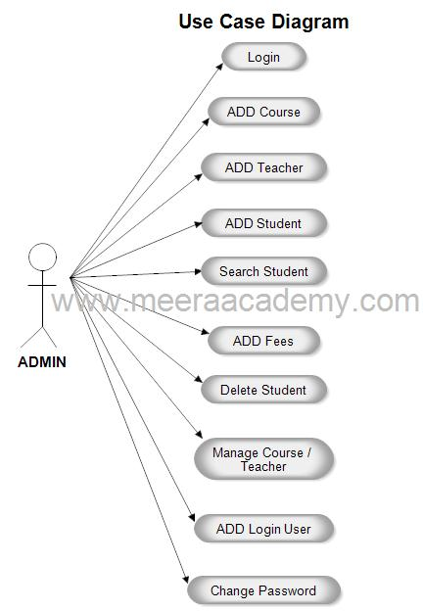
4.1 Use case diagram for Admin

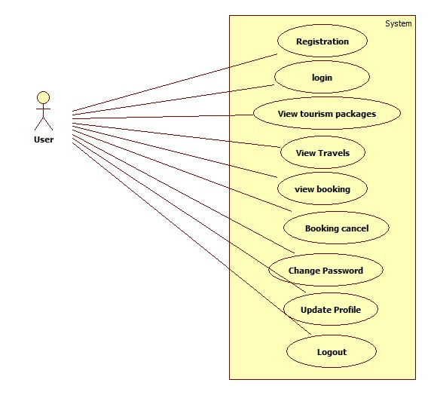
4.2 Use case diagram for User
4.3 Activity Diagram
An activity diagram is a variation or special case of a state machine, in which the states are activities representing the performance of operations and the transitions are triggered by the completion of the operations. The purpose of an activity diagram is to provide a view of flows and what is going on inside a use case or among the classes. However, activity diagram can also be used to represent a class's method implementation.
In this activity diagram first, the faculty opens the interface, and enters the password. If is valid go to the display options phase. If it is not valid reenter the correct password. In that display options select the option and do the work that option for example diary maintenance, marks entry ect. then appropriate results will be displayed, if you want to more go to select options statements otherwise logout the system.
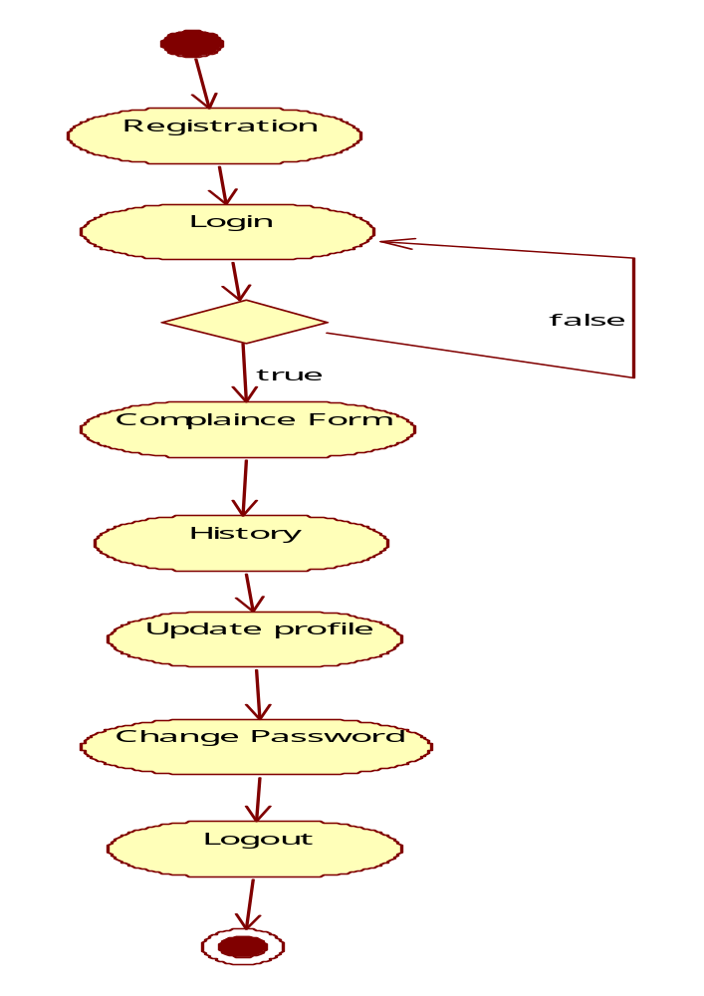
`4.3 Activity diagram for User
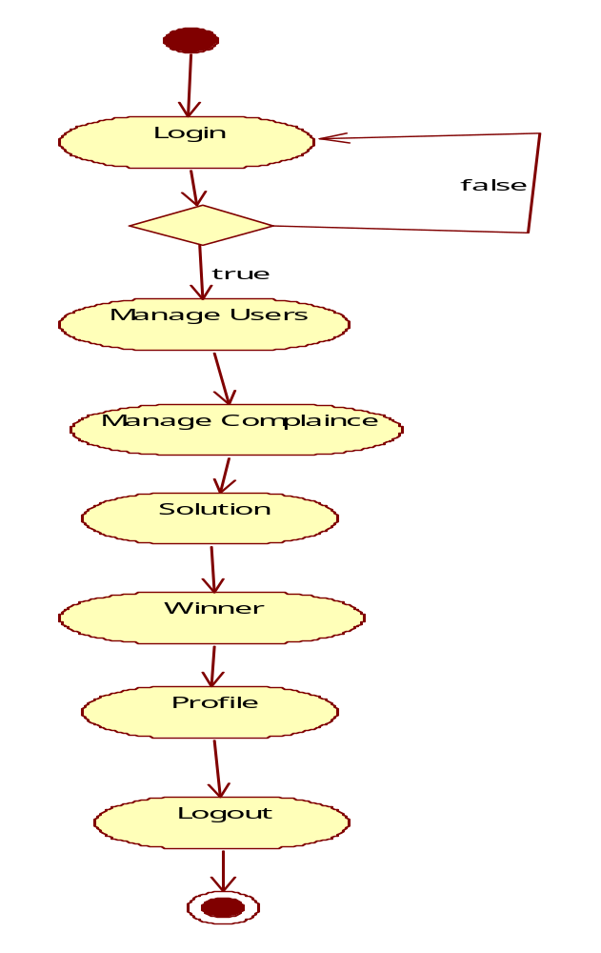
`4.4 Activity diagram for Admin
4.4 Sequence Diagram
A sequence diagram is an interaction diagram that shows how objects operate with one another and in what order. It is a construct of a message sequence chart.
A sequence diagram shows object interactions arranged in time sequence. It depicts the objects and classes involved in the scenario and the sequence of messages exchanged between the objects needed to carry out the functionality of the scenario. Sequence diagrams are typically associated with use case realizations in the Logical View of the system under development. Sequence diagrams are sometimes called event diagrams or event scenarios.
A sequence diagram shows, as parallel vertical lines (lifelines), different processes or objects that live simultaneously, and, as horizontal arrows, the messages exchanged between them, in the order in which they occur. This allows the specification of simple runtime scenarios in a graphical manner.
Diagram Notations:
Class Roles or Participants
Class roles describe the way an object will behave in context. Use the UML object symbol to illustrate class roles, but don't list object attributes.
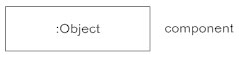
Activation or Execution Occurrence
Activation boxes represent the time an object needs to complete a task. When an object is busy executing a process or waiting for a reply message, use a thin gray rectangle placed vertically on its lifeline.
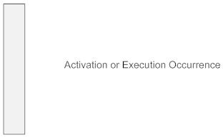
Messages
Messages are arrows that represent communication between objects. Use half-arrowed lines to represent asynchronous messages. Asynchronous messages are sent from an object that will not wait for a response from the receiver before continuing its tasks. For message types, see below.
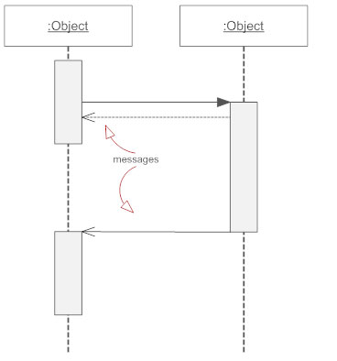
Lifelines
Lifelines are vertical dashed lines that indicate the object's presence over time.
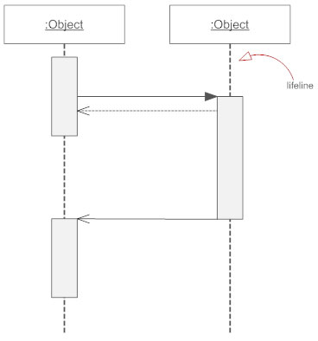

Destroying Objects
Objects can be terminated early using an arrow labeled "<< destroy >>" that points to an X. This object is removed from memory. When that object's lifeline ends, you can place an X at the end of its lifeline to denote a destruction occurrence.
Loops
A repetition or loop within a sequence diagram is depicted as a rectangle. Place the condition for exiting the loop at the bottom left corner in square brackets [ ].
Types of Messages in Sequence Diagrams
Synchronous Message
A synchronous message requires a response before the interaction can continue. It's usually drawn using a line with a solid arrowhead pointing from one object to another.

Asynchronous Message
Asynchronous messages don't need a reply for interaction to continue. Like synchronous messages, they are drawn with an arrow connecting two lifelines; however, the arrowhead is usually open and there's no return message depicted.

Reply or Return Message
A reply message is drawn with a dotted line and an open arrowhead pointing back to the original lifeline.

Self Message
A message an object sends to itself, usually shown as a U-shaped arrow pointing back to itself.
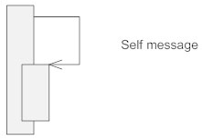
Create Message
This is a message that creates a new object. Similar to a return message, it's depicted with a dashed line and an open arrowhead that points to the rectangle representing the object created.
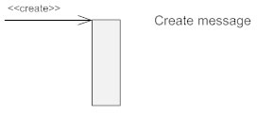
Delete Message
This is a message that destroys an object. It can be shown by an arrow with an x at the end.
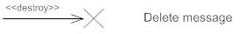
Found Message
A message sent from an unknown recipient, shown by an arrow from an endpoint to a lifeline.
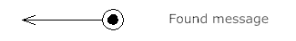
Lost Message
A message sent to an unknown recipient. It's shown by an arrow going from a lifeline to an endpoint, a filled circle or an x.
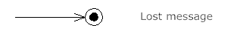

: Admin
Admin
System
Database
1 : login()
2 : Send request()
3 : get interface()
4 : login successfully()
5 : Manage User()
6 : Stores Complaince ()
7 : View Complaince()
8 : Complained succesfully()
9 : Manage Complaince ()
10 : Stores Complaince ()
11 : view Complaince ()
12 : Complaince successfully()
13 :Solution Created()
14 : Store Solution()
15 : view Solution details()
16 : Complaint Solved successfully()
17 : manage Winner Detials()
18 : Stores Winner details()
19 : fetch Winner details()
20 : Manage Winner successfully()
21 : Logout()
22 : Stores travels()
23 : manage travels successfully()
24 : Fetch travels()
25 : Manage bookings()
26 : Stores booking details()
27 : user booking details()
28 : Manage bookin successfully()
29 : manage contacts()
30 : Stores contact details()
31 : view contacts()
32 : manage contacts successfully()
33 : Change password()
34 : Send Request()
35 : get interface()
36 : change password successfully()
37 : logout()
38 : logout successfully()
4.5 Sequence diagram for Admin
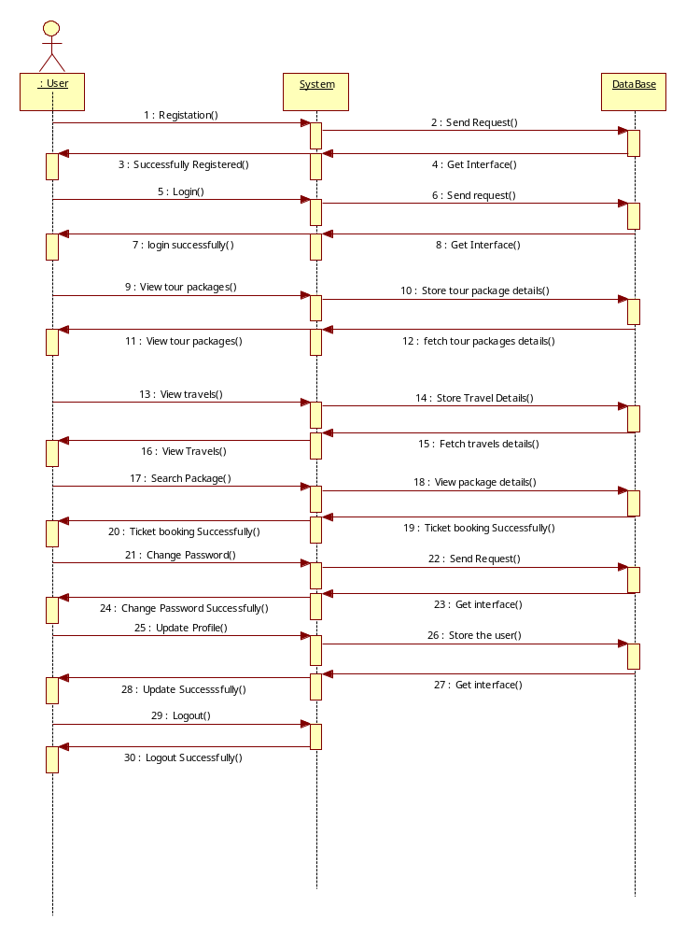
4.6 Sequence diagram for User
4.5 Data Flow Diagram
A data flow diagram is graphical tool used to describe and analyze movement of data through a system. These are the central tool and the basis from which the other components are developed. The transformation of data from input to output, though processed, may be described logically and independently of physical components associated with the system. These are known as the logical data flow diagrams. The physical data flow diagrams shows the actual implements and movement of data between people, departments and workstations.
A full description of a system actually consists of a set of data flow diagrams. Using two familiar notations Yourdon, Gane and Sarson notation develops the data flow diagrams. Each component in a DFD is labeled with a descriptive name. Process is further identified with a number that will be used for identification purpose. The development of DFD’s is done in several levels. Each process in lower level diagrams can be broken down into a more detailed DFD in the next level. The lop-level diagram is often called context diagram. It consists a single process bit, which plays vital role in studying the current system. The process in the context level diagram is exploded into other process at the first level DFD.
The idea behind the explosion of a process into more process is that understanding at one level of detail is exploded into greater detail at the next level. This is done until further explosion is necessary and an adequate amount of detail is described for analyst to understand the process.
Larry Constantine first developed the DFD as a way of expressing system requirements in a graphical from, this lead to the modular design.
A DFD is also known as a “bubble Chart” has the purpose of clarifying system requirements and identifying major transformations that will become programs in system design. So it is the starting point of the design to the lowest level of detail. A DFD consists of a series of bubbles joined by data flows in the system.
Constructing A DFD
Several rules of thumb are used in drawing DFD’s:

1. Process should be named and numbered for an easy reference. Each name should be representative of the process.
- The direction of flow is from top to bottom and from left to right. Data traditionally flow from source to the destination although they may flow back to the source. One way to indicate this is to draw long flow line back to a source. An alternative way is to repeat the source symbol as a destination. Since it is used more than once in the DFD it is marked with a short diagonal.

- When a process is exploded into lower level details, they are numbered.

- The names of data stores and destinations are written in capital letters. Process and dataflow names have the first letter of each work capitalized.
A DFD typically shows the minimum contents of data store. Each data store should contain all the data elements that flow in and out.
Questionnaires should contain all the data elements that flow in and out. Missing interfaces redundancies and like is then accounted for often through interviews.
Notations:
Data Flow: Data move in a specific direction from an origin to a destination. The data flow is a "packet" of data.

Process: People, procedures or devices that produce data. The physical component is not identified.

Source or Destination of data: External sources or destinations of data, which may be people or organizations or other entities.

Data Store: Here, the data referred by a process in the system.

Context level Diagram
4.6 E-R Diagram
The Entity-Relationship Diagram depicts a relationship between data objects. The Entity-Relationship diagram is the notation that is used to conduct the data modeling activity. The attributes of each object noted in the Entity-Relationship Diagram can be described using a data object description.
At first a set of primary components are identified for Entity-Relationship Diagram that is data object, attributes, relationship and various type indicator. Data objects are represented by labeled rectangles. Relationships are indicated with labeled lines connecting object.
Data modeling and Entity-Relationship diagram provide the analysis with a concise notation for examining data within the context of data processing application.
Entity Classes and Attributes:
- Entity class is represented by rectangles.
- Attributes are represented by ovals.
- Key attributes is represented by an underline.
- Multi- value attribute is represented with an oval with a double border.
- Derived attribute is represented with an oval dashed border.
- Composite attribute is represented with an oval that connects to additional ovals.
Notations of E-R Diagram

Entity set

Attributes

Relationship set

Relationship

Primary key
A

Multi-valued attributes

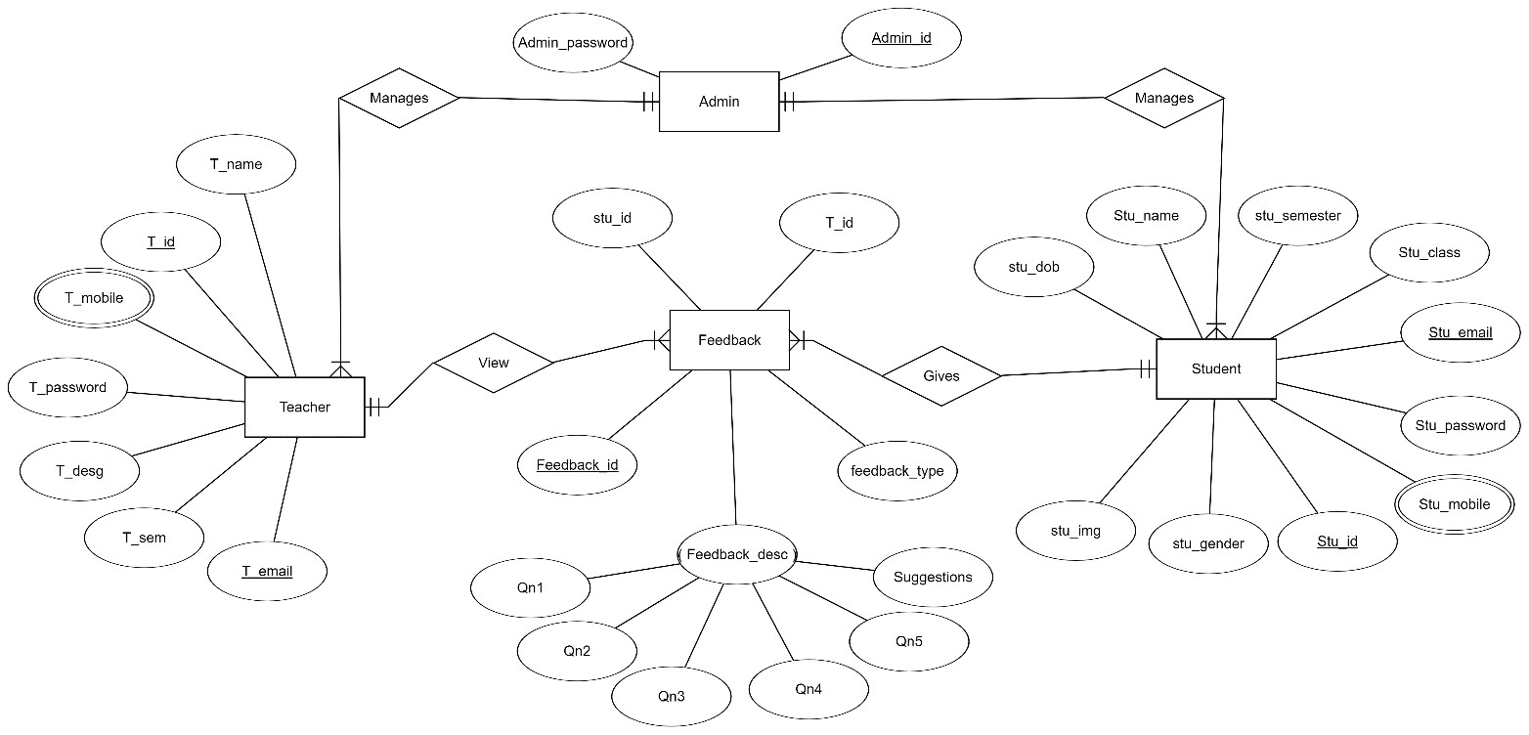
4.7 Data Dictionary
In the Analysis, we identify so many controls and functions on the project. So the object, which represents the controls and functions, are to be organized. This is accomplished with the data dictionary.
A DATA DICTIONARY (DD) as the name implies, is a repository of information about data. In some database systems the stored definitions of data (called schema) provide all the necessary data dictionary information in others, the Data Dictionary is supplementary. The information in the Dictionary is about types of data and uses of data.
The data Dictionary provides lists of data items sequenced alphabetically classification, keyword etc. The Data Dictionary provides a consistent official description of data as well as consistent data names for programming and retrieval. The advantages of a Data Dictionary are not only consistency of data description services many purposes.
Data Dictionaries may be used by the Database Administrator to enforce standards for names and description; those who create data must follow these standards. Creating and Data Dictionary requires significant effort to remove past inconsistencies and ambiguity.
Field Names | Description
User name | Admin Username
Password | Admin password
Id | Complaint Identification Number
Email_id | Feedback Emailid
Problem | Feedback Problem
Problem image | Feedback problem image
Postdate | Feedback Postdate
Id | Solution Identification Number
Problem | Solution Problem
Solution | Solution Reason
Regdate | Solution Registration Date
Updationdate | Solution Updating date
Id | User Identification Number
Full name | User Full Name
Mobile no | User Mobile Number
Emailid | User Emailid
Password | User Password
Pin code | User Pin code
Regdate | User Registration Date
Updating date | User Updating Date

5. System Requirements
System Requirements gives the idea about what are the necessary things that are needed for proposed system, which plays very important role in the development of the any system. This chapter deals with what are hardware components that are needed for the system, application software that are required for the development of the system. Requirement specification plays an important role to create quality software solution. Requirements are defined and analyzed to assess the clarity
Requirements are represented in a manner that ultimately leads to successful software implementation. Each requirement must be consistent with the overall objective. The development of this project deals with the following requirements.
- Hardware Requirements
- Software Requirements
5.1 Hardware Requirements
The selection of hardware is very important in the existence and proper working of any software. In the selection of hardware, the size and the capacity requirements are also important. These are the minimum requirements we used to run proposed system
- HARD DISK : 150 GB Hard disk Recommended
- RAM : 2 GB RAM Minimum
- PROCESSOR : Intel core i3
5.2 Software Requirements
The software requirements specification is produces of the analysis tasks. One of the most difficult tasks is, that the selection of the software, once system requirement is known by determining whether a particular software package fits the requirements.
- Operating System: Windows 7ultimat
- Front: HTML5/CSS
- Database: MYSQL
- Web Server: XAMPP
6. System Design
6.1 Introduction
Design is the first step in the development phase for any engineering product (or) system. It may be defined as “The process of applying various techniques and principles for the purpose of defining a device, a process, or a system insufficient detail to permit its physical realization”.
Software design is an iterative process through which requirements are translated into a ‘blue print’ for constructing software. The design is represented at a high level of abstraction, a level that can be directly translated to a specific data, functional behavior requirements.
Preliminary design is concerned the transformation of requirements into a data and software architecture. Detail design focuses on refinements to the architectural representation that leads to detail data structure and algorithm representation for software.
In the design step, the element of the analysis model gets converted in to a data design, architecture, an interface design and procedural design.
- The data design transforms the information domain model created during analysis into data structure that will be required to implement software.
- The architectural design defines the relationship among structural elements of the program.
6.2 Layered Architecture
Layers is an architectural design pattern that structures applications so they can be decomposed into groups of subtasks such that each group of subtasks is at a particular level of abstraction. The traditional 3-tier client server model which separates application functionality into three distinct abstractions.
GUI
Business Rules
Data Base

6.3 Design principles
Effective interfaces are visually apparent and forgiving, installing in their users a sense of control. Users quickly see the breadth of their options, grasp how to achieve their goals, and do their work. Effective interfaces do not concern the inner workings of the system. Work is carefully and continuously saved, with full option for the user to undo any activity at any time.
In order to design interface that exhibit these characteristics, identifies a set of overriding design principles:
Anticipating- a webapp should be designed so that it anticipates the users next move. The designer of the webapp should anticipate that the user might request a download of the driver and should provide navigation facilities that allow this to happen without requiring the user to search for this capability.
Communication- the interface should communicate the status of an activity initiated by the user. Communication can be obvious or subtle.
Consistency- the use of navigation controls, menus, icons, and aesthetics should be consistent throughout the webapp.
Controlled autonomy- the interface should facilitate user movement throughout the webapp, but it should do so in a manner that enforces navigation conventions that have been established for the application.
Efficiency- the design of the webapp and its interface should optimize the users work efficiency, not the efficiency of the web engineer who designs and builds it or the client server environment that executes it.
Flexibility- the interface should be flexible enough to enable some users to accomplish tasks directly and others to explore the webapp in a somewhat random fashion.
Focus- the webapp interface should stay focused on the user tasks at hand
Fit’s law- this is an effective method of modeling rapid, aimed movements, where one appendage starts at rest at a specific start position, and moves to rest within a target area.

6.4 Database design
Database design defines the method of data organization. The operational data is stored in entities. Relationship between entities makes up data structure. Data structuring is refined through the process of normalization.
Entities of the proposed system are normalized up to the normal form. These follows that Foreign key is defined for every entity that has unique identification property. Foreign keys are also defined wherever applicable to ensure data integrity and data consistency. For developing an efficient database, we have to fulfill certain conditions such as
- Control Redundancy
- Data Independence
- Accuracy and Integrity
- Recovery from failure
- Privacy and Security
The loading of the text files to the SQL server tables, using SQL loaders was great learning experience, as we had to be very specific about the details for loading to be successful.
6.4. Normalization
Normalization of relation schema is done to eliminate insertion and deletion anomalies that exist in databases. Normalization is a step-by-step reversible process of converting given collection of relations to some desirable form in which the relations have a progressively simpler and regular structure.
The objectives of Normalization are:
  - To make it feasible to represent any relation in the database.
  - To obtain powerful retrieval algorithms based on a simpler collection of relational operations.
  - To free relations from undesirable insertions, update and deletion dependencies.
A relation R is said to be in 1NF if all underlying domains contain atomic values only.
A relation R is to said to be in 2NF if and only if it is in 1NF and every non-key attribute is non-transitively dependent on the Foreign key.
A relation R is to said to be in 3NF if it is in 2NF and its non-key attribute is non-transitively dependent on its Foreign key.
All the tables that have been designed for developing this system follow 2nd Normalization form.

6.5 Database Tables
Admin
SR. NO. | ATTRIBUTE NAME | ATTRIBUTE MEANING | ATTRIBUTE VALUE
(1) | Id | Admin’s id | Varchar (10)
(2) | Password | Admin’s Password | Varchar (30)

Teacher Table
SR. NO. | ATTRIBUTE NAME | ATTRIBUTE MEANING | ATTRIBUTE VALUE
(1) | Id | Teacher’s id | Varchar (10)
(2) | Password | Teacher’s Password | Varchar (30)
(3) | Mobile | Mobile number of teachers | Varchar (11)
(4) | Designation | Teacher’s Designation | Varchar (10)
(5) | Sem | Semester the teacher is teaching | Int (10)
(6) | Email | Email id of teacher | Varchar (50)
(7) | Name | Teacher’s Name | Varchar (50)

Feedback Table
SR. NO. | ATTRIBUTE NAME | ATTRIBUTE MEANING | ATTRIBUTE VALUE
(1) | Id | Feedback’s id | Varchar (10)
(2) | T_id | Teacher’s id | Varchar (10)
(3) | Stu_id | Student’s Id | Varchar (10)
(4) | Type | Feedback Type | Varchar (10)
(5) | Qn1 | Response of Question 1 | Enum (‘1’,’2’,’3’,’4’,’5’)
(6) | Qn2 | Response of Question 2 | Enum (‘1’,’2’,’3’,’4’,’5’)
(7) | Qn3 | Response of Question 3 | Enum (‘1’,’2’,’3’,’4’,’5’)
(8) | Qn4 | Response of Question 4 | Enum (‘1’,’2’,’3’,’4’,’5’)
(9) | Qn5 | Response of Question 5 | Enum (‘1’,’2’,’3’,’4’,’5’)
(10) | Qn6 | Response of Question 6 | Enum (‘1’,’2’,’3’,’4’,’5’)
(11) | Qn7 | Response of Question 7 | Enum (‘1’,’2’,’3’,’4’,’5’)
(12) | Qn8 | Response of Question 8 | Enum (‘1’,’2’,’3’,’4’,’5’)
(13) | Suggestion | Any personal suggestion the student want to give to the teacher. | Varchar (200)
(14) | Suggestion | Any personal suggestion the student want to give to the teacher. | Varchar (200)

6.6 Sample Coding
PHP code for Home Page:
<?php
session start ();
require('dbconfig.php')?>
<!DOCTYPE html>
<html lang="eng">

<head>

<meta charset="utf-8">
<meta http-equiv="X-UA-Compatible" content="IE=edge">
<meta name="viewport" content="width=device-width, initial-scale=1">
<meta name="description" content="">
<meta name="author" content="">
<title>Online feedback System</title>

<! -- Bootstrap Core CSS -->
<link href="css/bootstrap.min.css" rel="stylesheet">

<! -- Custom CSS -->
<link href="css/modern-business.css" rel="stylesheet">

<! -- Custom Fonts -->
<link href="font-awesome/css/font-awesome.min.css" rel="stylesheet" type="text/css">

</head>

<body>

<! -- Navigation -->
<nav class="navbar navbar-default navbar-fixed-top" role="navigation" style="background: #66CCFF">
<div class="container" >
<! -- Brand and toggle get grouped for better mobile display -->
<div class="navbar-header">
<button type="button" class="navbar-toggle" data-toggle="collapse" data-target="#bs-example-navbar-collapse-1">
<span class="sr-only">Toggle navigation</span>
<span class="icon-bar"></span>
<span class="icon-bar"></span>
<span class="icon-bar"></span>
</button>
<a class="navbar-brand" href="index. Php" style="color: #FFFFFF">Online feedback System</a>

</div>
<! -- Collect the nav links, forms, and other content for toggling -->
<div class="collapse navbar-collapse" id="bs-example-navbar-collapse-1">
<ul class="nav navbar-nav navbar-right">

<li style="color: #FFFFFF">
<a style="color: #FFFFFF" href="index. Php"><i class="fa fa-home fa-fw"></i>Home</a>
</li>

<li style="color: #FFFFFF">
<a style="color: #FFFFFF" href="index.php?info=about"><i class="fa fa-home fa-fw"></i>About</a>
</li>

<li><a style="color: #FFFFFF" href="index.php?info=registration"><i class="fa fa-sign-out fa-fw"></i>Registration</a></li>

<li class="dropdown">
<a style="color: #FFFFFF" href="#" class="dropdown-toggle" data-toggle="dropdown" href="#"><i class="fa fa-sign-in fa-fw"></i>Login
<span class="caret"></span></a>
<ul class="dropdown-menu">

<li><a href="index.php?info=login">Student</a></li>
<li><a href="index.php?info=faculty login">Faculty</a></li>
<li><a href="admin">Admin</a></li>
</ul>
</li>

<li>
<a style="color: #FFFFFF" href="index.php?info=contact"><i class="fa fa-phone fa-few"></i>Contact</a>
</li>

</ul>
</div>
<! -- /. navbar-collapse -->
</div>
<! -- /.container -->
</nav>

<?php
@$info=$_GET['info'];
If ($info! ="")
{

if($info=="about")
{
Include ('about. Php');
}

else if($info=="contact")
{
Include ('contact. Php ');
}

else if($info=="login")
{
Include ('login. Php');
}

else if ($info=="faculty login")
{
include('faculty_login.php');
}

else if($info=="registration")
{
Include ('registration. Php');
}
}
else
{
?>
<! -- slider start -->
<header id="my Carousel" class="carousel slide">
<! -- Indicators -->
<ol class="carousel-indicators">
<li data-target="#my Carousel" data-slide-to="0" class="active"></li>
<li data-target="#my Carousel" data-slide-to="1"></li>
<li data-target="#my Carousel" data-slide-to="2"></li>
</ol>

<! -- Wrapper for slides -->
<div class="carousel-inner">
<div class="item active">

<div class="fill" style="background-image:url('images/feedback.jpg');"></div>
<div class="carousel-caption">
<header>
<p>Welcome To</p>
<h2>Online Feedback System</h2>
</header>
</div>
</div>

<div class="item">
<div class="fill" style="background-image:url('images/feedback1.jpg');"></div>
<div class="carousel-caption">
<header>
<p>Creating</p>
<h2>A new way to give feedback</h2>
</header>
</div>
</div>

<div class="item">
<div class="fill" style="background-image:url('images/feedback3.jpg');"></div>
<div class="carousel-caption">
<header>
<p>Our moto</p>
<h2>We bring changes</h2>
</header>
</div>
</div>

<! -- Controls -->
<a class="left carousel-control" href="#my Carousel" data-slide="prev">
<span class="icon-prev"></span>
</a>
<a class="right carousel-control" href="#my Carousel" data-slide="next">
<span class="icon-next"></span>
</a>
</header>
<! -- slider -->

<! -- Page Content -->
<div class="container">

<div class="row">
<div class="col-lg-12">

<div class="col-sm-10" style="margin-top:60px; margin-bottom:80px">
<h2>About Faculty feedback System</h2>
Student Feedback system for College in PHP (Source code)
Here we have developed a faculty feedback system, which is generally used in the college to rate the faculty based on the performance...Here we have 2 modules such as administrator, student.

Administrator is the one who creates the student account by adding all student info and assigning the username and password.
Admin als0 checks the result once all students entered the feedback.
We can start the development from the login page, where we have given the option to login as admin and student...Here since we have only one admin account, so no need to create a database to store admin info...so the admin username is "admin" and password is "Sandeep"...select admin in the radio button and login

You can perform all admin actions such as login to the account and check result.

If you entered the student user and password and selected student option, then it will show all student information and let you enter the feedback based on the subject.

Before we can look into the php code, you need to create a database called "feed" with two tables in if. One as student and another one as take

</div>

<?php}?>
</div>

</div>
<! -- /.container -->

<! --<div class="navbar-fixed-bottom nav navbar-inverse text-center" style="padding:15px; height:40px; background: #66CCFF">
<span style="color: #FFFFFF">Developed By ....... <a href="http://www.phptpoint.com">Phptpoint.com</a> </span>
</div>---->
<! -- jQuery -->
<script src="css/jquery.js"></script>

<! -- Bootstrap Core JavaScript -->
<script src="css/bootstrap.min.js"></script>

<! -- Script to Activate the Carousel -->
<script>
$(‘. carousel'). carousel ({
interval: 5000 //changes the speed
})
</script>

</body>

</html>

PHP code for Registration:
<?php
extract($_POST);
if(isset($save))
{
//check user already exists or not
$sql=mysqli_query ($conn, “select * from user where email='$e'");

$r=mysqli_num_rows($sql);

if($r==true)
{
$err= "<font color='red'><h3 align='center'>This user already exists</h3></font>";
}
else
{
//dob
$dob=$yy."-”. $mm."-”. $dd;

//hobbies
$hob=implode (",”, $hob);

//image
$image Name=$_FILES['img’] ['name'];

//encrypt your password
$pass=md5($p);

$query="insert into user values ('','$n','$e','$pass','$mob','$pro','$sem','$gen','$hob','$imageName','$dob', now ())";
mysqli_query ($conn, $query);

//upload image

mkdir("images/$e");
move_uploaded_file($_FILES['img'] ['tmp_name'],"images/$e/”. $_FILES['img'] ['name']);

$err="<font color='blue'><h3 align='center'>Registration successful !!<h3></font>";

}
}

?>

<div class="row">
<div class="col-sm-2"></div>
<div class="col-sm-8">
<form method="post" enctype="multipart/form-data">
<table class="table table-bordered" style="margin-bottom:50px">
<caption><h2 align="center">Registration Form</h2></caption>
<Tr>
<Td colspan="2"><?php echo @$err;></Td>
</Tr>

<tr>
<td>Enter Your name</td>
<Td><input type="text" name="n" class="form-control" required/></td>
</tr>
<tr>
<td>Enter Your email </td>
<Td><input type="email" name="e" class="form-control" required/></td>
</tr>

<tr>
<td>Enter Your Password </td>
<Td><input type="password" name="p" class="form-control" required/></td>
</tr>

<tr>
<td>Enter Your Mobile </td>
<Td><input type="text" name="mob" class="form-control" required/></td>
</tr>

<tr>
<td>Select Your Programme</td>
<Td><select name="pro" class="form-control" required>

<option>BCA</option>
<option>MCA</option>
<option>BTech</option>
<option>MTech</option>
</select>
</td>
</tr>

<tr>
<td>Select Your Semester</td>
<Td><select name="Sem" class="form-control" required>

<option>I</option>
<option>ii</option>
<option>iii</option>
<option>iv</option>
<option>v</option>
<option>vi</option>
<option>vii</option>
<option>viii</option>
</select>
</td>
</tr>

<tr>
<td>Select Your Gender</td>
<Td>
Male<input type="radio" name="gen" value="m"/>
Female<input type="radio" name="gen" value="f"/>
</td>
</tr>

<tr>
<td>Choose Your hobbies</td>
<Td>
Reading<input value="reading" type="checkbox" name="hob []"/>
Singing<input value="sing in" type="checkbox" name="hob []"/>

Playing<input value="playing" type="checkbox" name="hob []"/>
</td>
</tr>

<tr>
<td>Upload Your Image </td>
<Td><input type="file" name="img" class="form-control" required/></td>
</tr>

<tr>
<td>Enter Your DOB</td>
<Td>
<select style="width:100px; float: left" name="yy" class="form-control" required>
<option value="">Year</option>
<?php
for ($i=1950; $i<=2016; $i++)
{
echo "<option> “. $i."</option>";
}
?>

</select>

<select style="width:100px; float: left" name="mm" class="form-control" required>
<option value="">Month</option>
<?php
for ($i=1; $i<=12; $i++)
{
echo "<option> “. $i."</option>";
}
?>

</select>

<select style="width:100px; float: left" name="dd" class="form-control" required>
<option value="">Date</option>
<?php
for ($i=1; $i<=31;$i++)
{
echo "<option>".$i."</option>";
}
?>

</select>

</td>
</tr>

<tr>

<Td colspan ="2" align="center">
<input type="submit" value="Save" class="btn btn-info" name="save"/>
<input type="reset" value="Reset" class="btn btn-info"/>

</td>
</tr>
</table>
</form>
</div>
<div class="col-sm-2"></div>
</div>
</body>
</html>

PHP code for Login Page:
<?php
extract($_POST);
if(isset($save))
{

If ($e=="" || $p=="")
{
$err="<font color='red'>fill all the fields first</font>";
}
else
{
$pass=md5($p);

$sql=mysqli_query ($conn, “select * from user where email='$e' and pass='$pass'");

$r=mysqli_num_rows($sql);

if($r==true)
{
$_SESSION['user’] =$e;
header ('location: user');
}

else
{

$err="<font color='red'>Invalid login details</font>";

}
}
}

?>
<div class="row">
<div class="col-sm-2"></div>
<div class="col-sm-8">

<form method="post">
<div class="row">
<div class="col-sm-4"></div>
<div class="col-sm-4"><h2>Login Form</h2></div>
</div>

<div class="row">
<div class="col-sm-4"></div>
<div class="col-sm-4"><?php echo @$err;?></div>
</div>

<div class="row" style="margin-top:10px">
<div class="col-sm-4">Enter Your Email</div>
<div class="col-sm-5">
<input type="email" name="e" class="form-control"/></div>
</div>

<div class="row" style="margin-top:10px">
<div class="col-sm-4">Enter Your Password</div>
<div class="col-sm-5">
<input type="password" name="p" class="form-control"/></div>
</div>
<div class="row" style="margin-top:10px">
<div class="col-sm-4"></div>
<div class="col-sm-8">
<input type="submit" value="Login" name="save" class="btn btn-info"/>

</div>
</div>
</form>
</div>
</div>
7. System Testing
Introduction
Testing is the process of detecting errors. Testing performs a very critical role for quality assurance and fro ensuring the reliability of software. The results of testing are used later on during maintenance also.
The aim of testing is often to demonstrate that a program works by showing that it has no errors. The basic purpose of testing phase is to detect the errors that may be present in the program. Testing is the process of executing a program with the intent of finding errors.
Testing Objectives
The main objective of testing is to uncover a host of errors, systematically and with minimum effort and time.
- Testing is a process of executing a program with the intent of finding error.
- A successful test is one that uncovers an as undiscovered error.
- A good test case is one that has a high probability of finding error, if it exists.
- The tests are inadequate to detect possibly present errors.
- The software more or less confirms to the quality and reliable standards.
Test Case Design
A rich variety of test case design methods have evolved for software. These methods provide the developer with a systematic approach to testing. More important, methods provide a mechanism that can help to ensure the completeness of tests and provide the highest likely hood of uncovering errors in software.Any engineering product can be tested in one of the two ways:
- Knowing the specified function that a product has been designed to perform.
- Knowing the internal working of a product.
Levels of testing
In order to uncover the errors, present in different phases we have the concept of levels of testing. The basic levels of testing are:
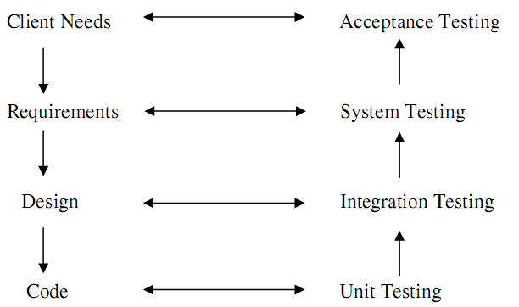

7.1 White Box Testing
This is a unit testing method where a each unit of “Sports Academy Management system” will be taken at a time and tested thoroughly at a statement level to find the maximum possible errors. I tested stepwise every piece of code, taking care that every statement in the code is executed at least once. The White Box testing is also called Glass Box Testing.
We have generated a list of test cases, sample data which is used to check all possible Combinations of execution paths through the code at every module level.
7.2 Black Box Testing
This testing method focuses on the functional requirements of the software. Here Module will be treated as a black box that will take some input and generate output. Output for a given set of input combinations are forwarded to other modules. Black Box Testing attempts to find the following types of errors
- Incorrect or missing functions
- Interface errors
- Errors in data structures or external data base access
- Performance errors
- Initialization errors and termination errors
All the forms have been executed and verified. Based on some sample input data, the generated output is verified whether the system is providing better results or not.
7.3 Unit testing
Unit testing focuses on the verification of code produced during coding phase and hence the goal is to test the interface in order to ensure that information property follows in and out of the program under unit test.In the “ Sports Academy Management” each service can be thought of a module. Each module has been tested by giving different sets of inputs. The inputs are validated when accepting from the user.
The goal here is to see whether the modules are integrated properly, the emphasis being on testing interfaces between modules. This activity can be considered as testing the design and hence the emphasis on testing module interactions.
In this project the main system is formed by integrating all the modules. When integrating all the modules, we have checked whether the integration effects working of the services by giving different combinations of inputs with which the two services run perfectly before integration.
7.4 Validation Testing
Validation Testing demonstrates traceability of software requirements. Validation succeeds when the software functions in expected manner. The major elements of this process are alpha and beta testing along with configuration reviews.
The validations that we carried through in” Sports Academy Management System” project are as follows:
Some inputs are made mandatory
Data validations are carried out
Every field in the screen should not exceed its maximum length.
At the culmination of integration testing, software is completely assembled as a package: In “Sports Academy Management System”, interfacing errors have been uncovered and corrected and a final series of software tests-validation testing may begin. Validation can be defined in many ways, but a simple definition is that validation succeeds when software functions in a manner that can be reasonably expected by the customer.
Software validation was achieved through a series of Black Box test that demonstrate conformity with the requirements. Validation test was succeeded because the software functions in a manner that can be reasonably expected by the customer.
7.5 Client Server Testing
In general, the testing of Client/Server software occurs at three different levels:
- Individual client applications are connected a “disconnected mod”, the operation of the server and the underlying network are not considered.
- The client software and associated server applications are tested in concert, but network are not explicitly exercised.
- The complete C/S architecture, including network operation and performance is tested.
The following are the testing approaches for C/S applications.
Applications Function tests
Here the functionality of applications is tested. In essence, the application is tested in standalone fashion in an attempt to uncover errors in its operation.
Server Tests
The coordination and data management functions of the server are tested. Server performance is also considered.
Database Tests
The accuracy and integrity of data stored by the server is tested. Transactions posted by client applications are examined to ensure that data is properly stored, updated and retrieved.

8. Implementation
Implementation is the process of converting a new or revises system design into an operational one. Apart from planning, the major tasks of preparing for implementation or education and training of users.
Implementation includes following activities:
- Obtaining and system hardware
- Providing access to the system
- Creating and updating the database
- Training the users on the new system Implementation Methods
There are four basic methods of implementation:
- Direct conversion
- Parallel conversion
- Pilot conversion
- Phasing conversion
Direct Conversion
Description
In this method the new one replaces the old system. This makes organization to fully relay on the new system.
Advantages
This method forces users to make the new system work. There are immediate benefits from new methods and controls.
Disadvantages
There is no other system to fall back on if difficulties arise with new system. This method also requires most careful planning.
Parallel Conversion
Description
In this method, the old system is operated along with the new system.
Advantages
This method offers greatest security. The old system can take over if errors are found in the new system or if some usage problems occur.
Disadvantages
This method doubles the operating costs also the new system may not get fair tail.
Pilot Conversion
Description
In this method the system is implemented to a small part of the organization. Based on the feedback, changes are made and the system is installed in the rest of the organization by one of the other methods.
Advantages
This method provides experience and live test before implementation.
Disadvantages
This method may give the impression that the old system is unreliable and not error free.
Phase Conversion
Description
In this method, the system is implemented gradually across all users.
Advantages
It allows some users to take advantages of the system early. It allows training and installing without unnecessary use of resources.
Disadvantages
A long phase-in causes user problems whether the project goes well of not.

9. Conclusions
The development of software include It meets the information requirements specified to a great extent. The system has been designed keeping in view the present and future requirements in mind and made very flexible. The system has been divided in modules so that each module has a separate entity making the modifications easy without affecting its design. There is always room for improvements in software, however efficient it may be. The CRM for online citizen complaint box is a web-based application for primarily providing training to the employees who provide customized solutions to meet organizational needs. This application software has been computed successfully and was also tested successfully by taking “test cases”. It is user friendly, and has required options, which can be utilized by the user to perform the desired operations. The software is developed using Php as front end and MySQL as back end in Windows environment.

Appendices
APPENDIX-A: User Manual
User manual is the guide to the users of the system it paves a path to the corresponding user top help him how to precede further in the proper understanding of the system. The interfaces of the system get familiar to the user, based on this manual only.
The first form is the login form where user has to enter his username and the password. Here three types of users are there.

APPENDIX-B:Test Screens
Screen1: This screen shows Home page
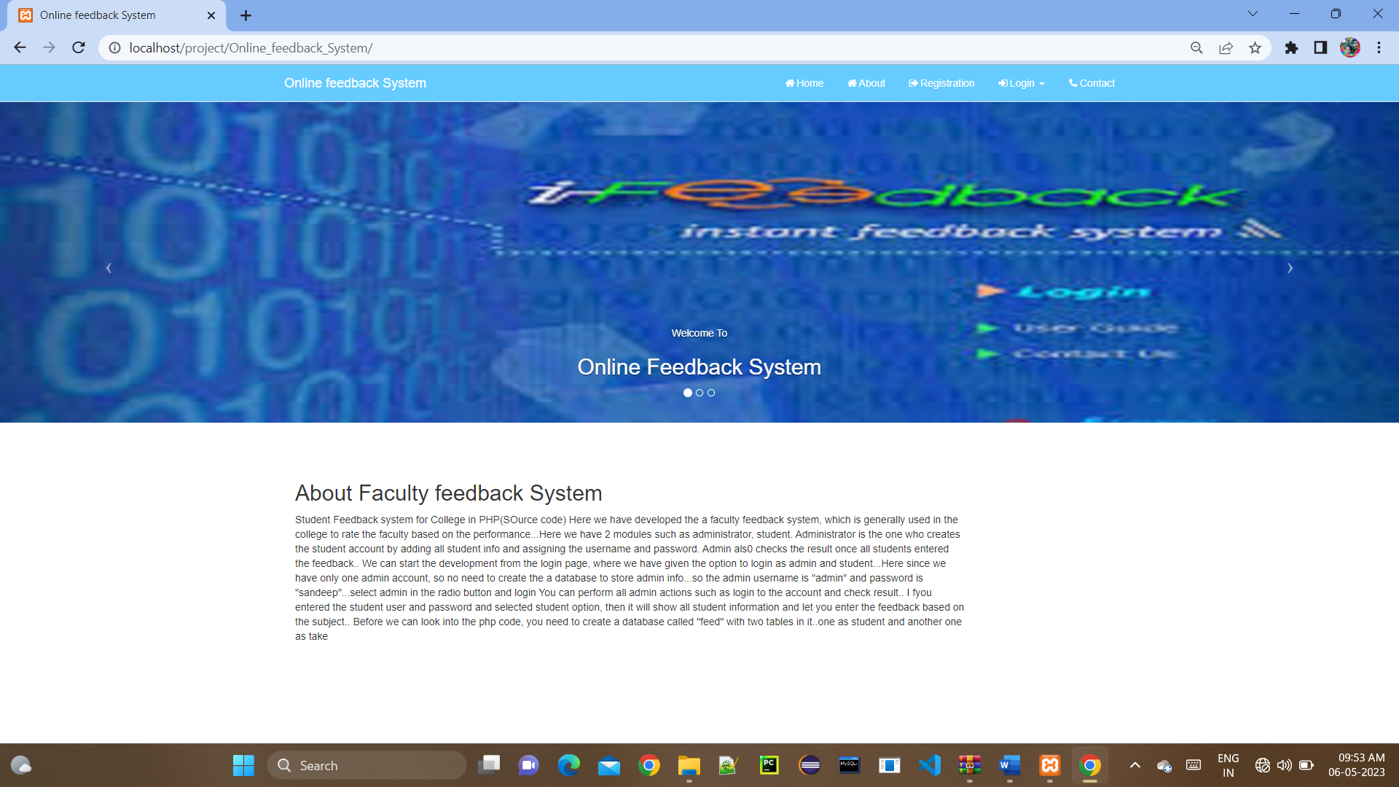

Screen2: This screen shows Contact Us page
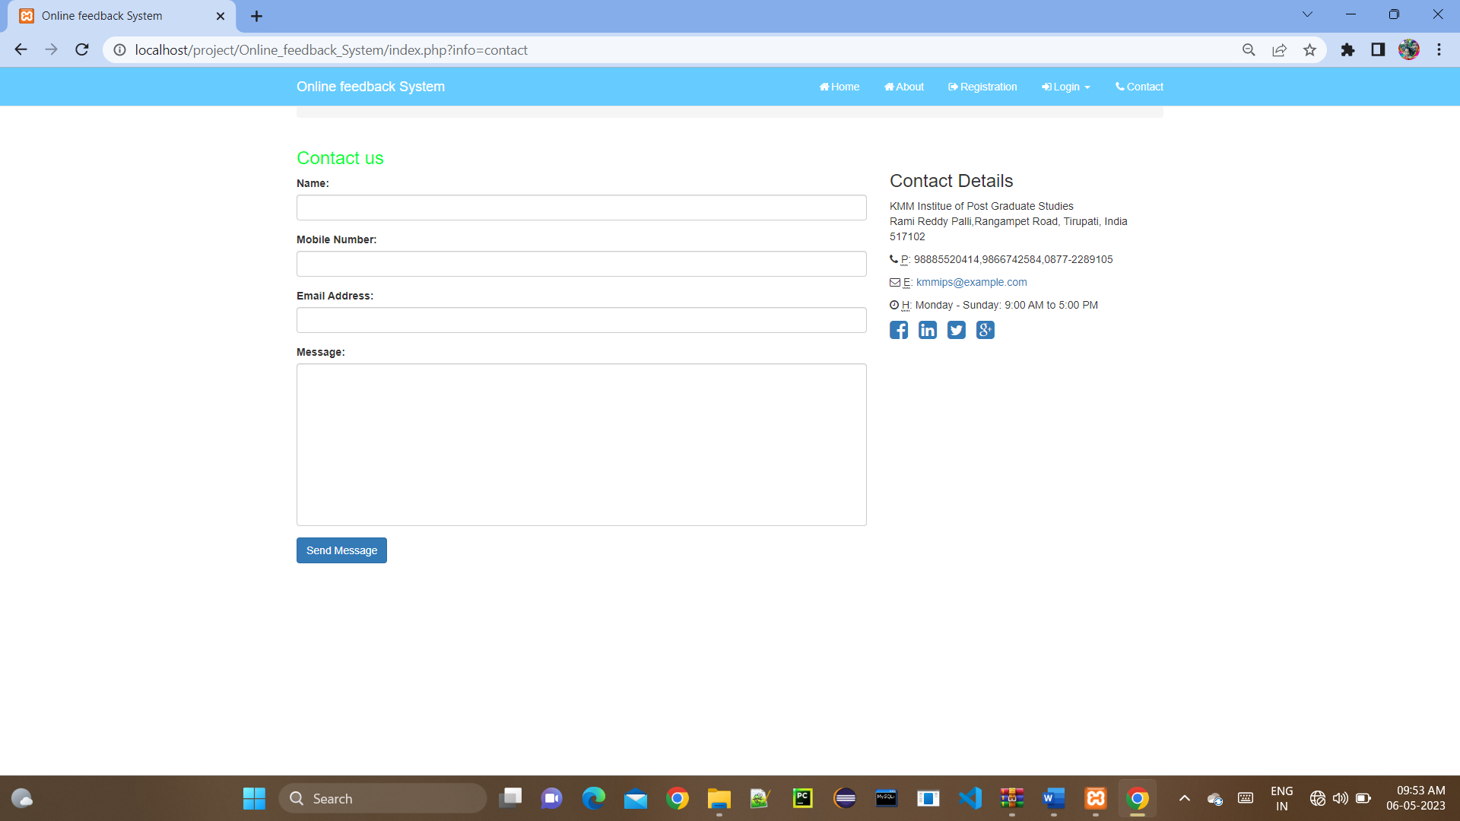

Screen3: This screen shows Student Registration Page
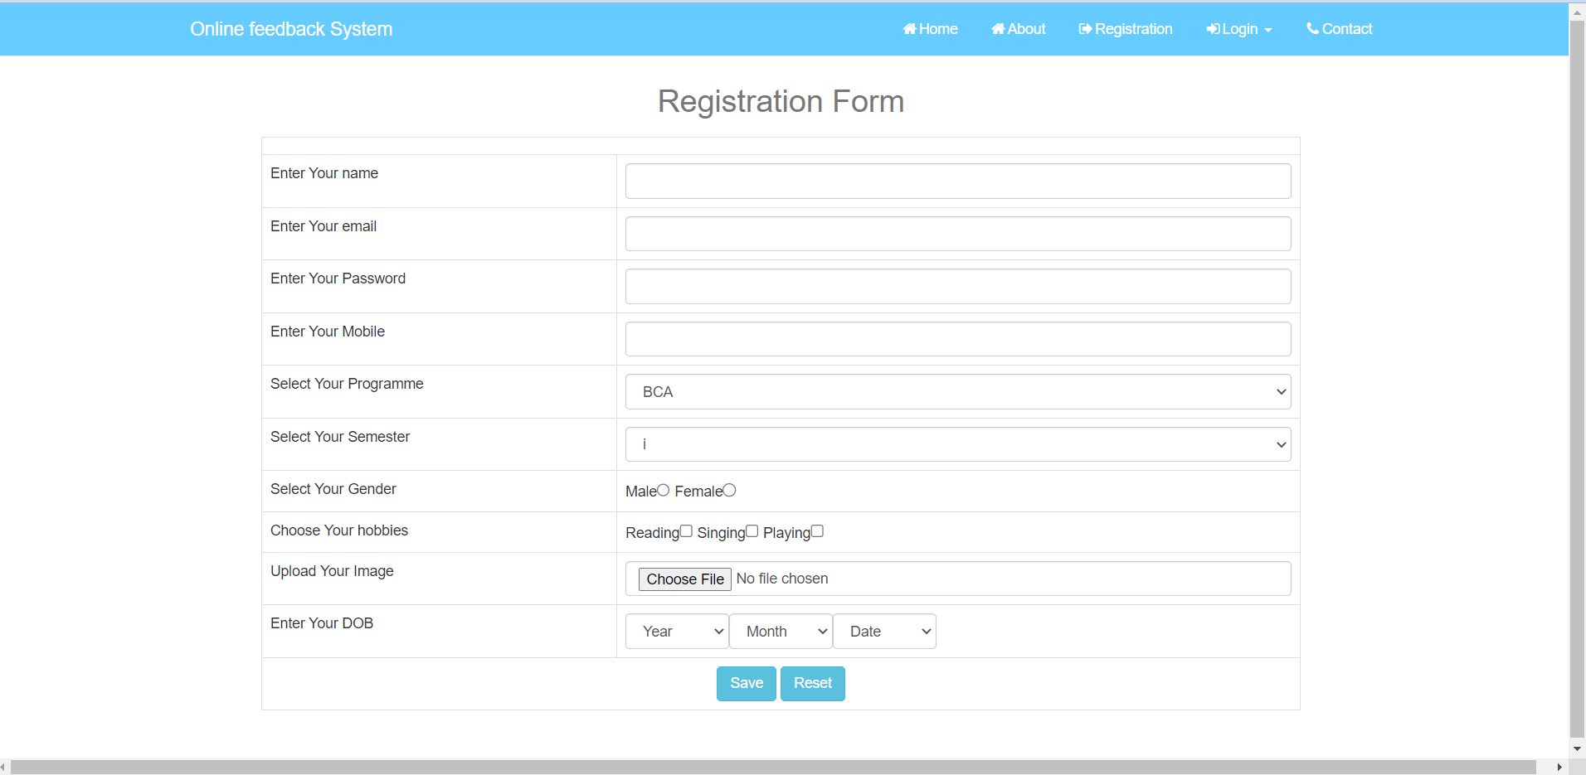

Screen4: This screen shows Student Login page
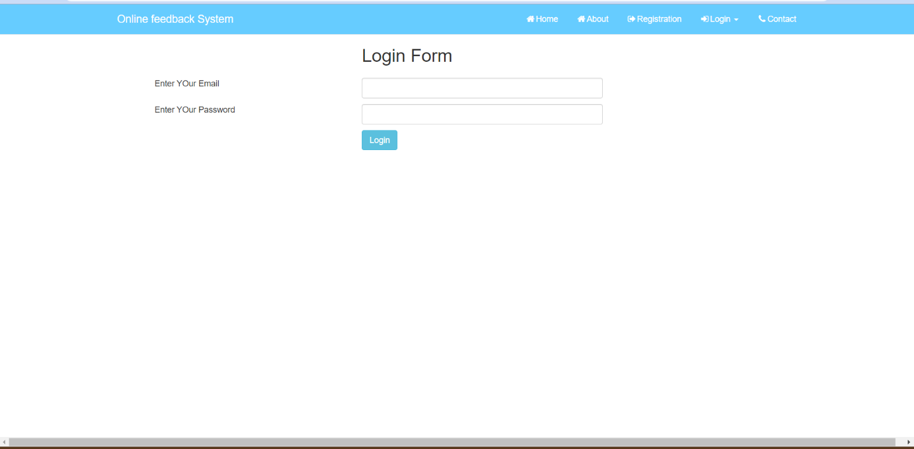

Screen5: This screen shows Student Feedback form page
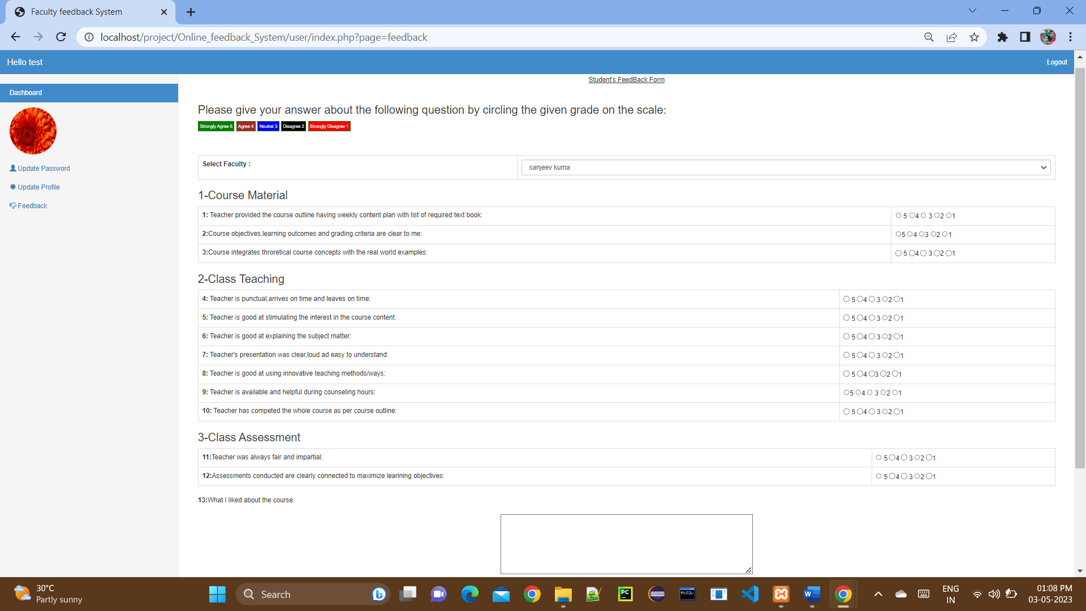

Screen 6: This screen shows View Feedbacks by Admin
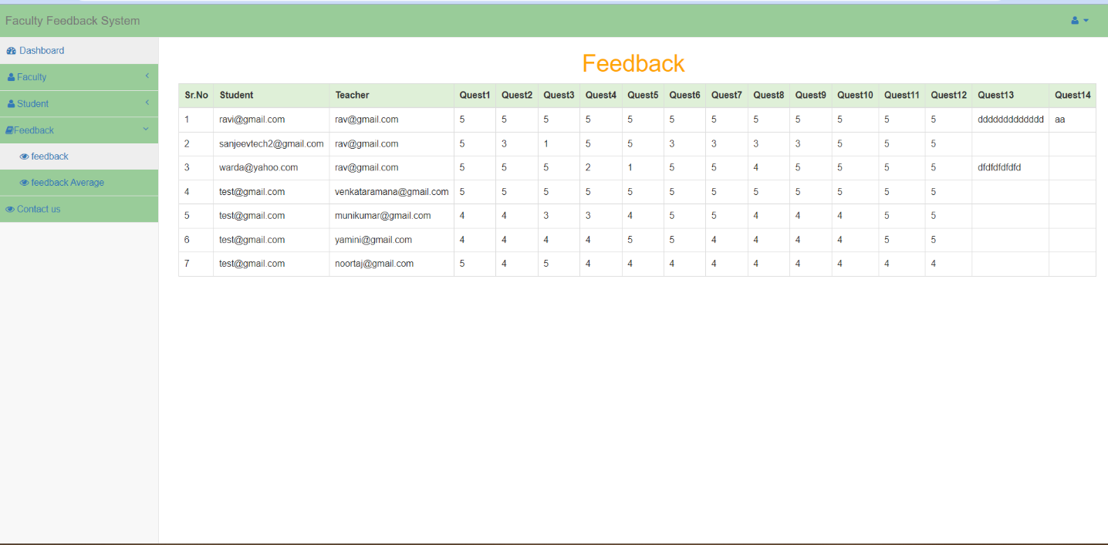

Bibliography
- BOOKS REFRENCES

- Bahrami Ali “Object Oriented Systems Development” McGraw Hill Editions, Computer Science Series, 2000
- Roger S Pressman “Software Engineering: A Practitioner’s Approach” McGraw-Hill International Edition
- Silberchatz, Korth, Sudarshan “Database System concepts” McGraw-Hill Publications, Fifth Edition.
- Steven Holzner “PHP: The Complete Reference”.
- Thomas Powell “HTML & CSS: The complete Reference” Fifth Edition

- WEBSITES REFERENCES

- https://www.w3schools.com/php/
- https://www.w3schools.com/
- https://www.w3schools.com/css/
- http://www.softwaretestingclass.com/software-testing-tools-list/

